To access the Federal and State withholding tax information in eCHRIS, the website is echris.phoenix.gov.
Enter your User ID, Password and select the Sign In button. To reset your password, please call the Help Desk at 602-534-4357.

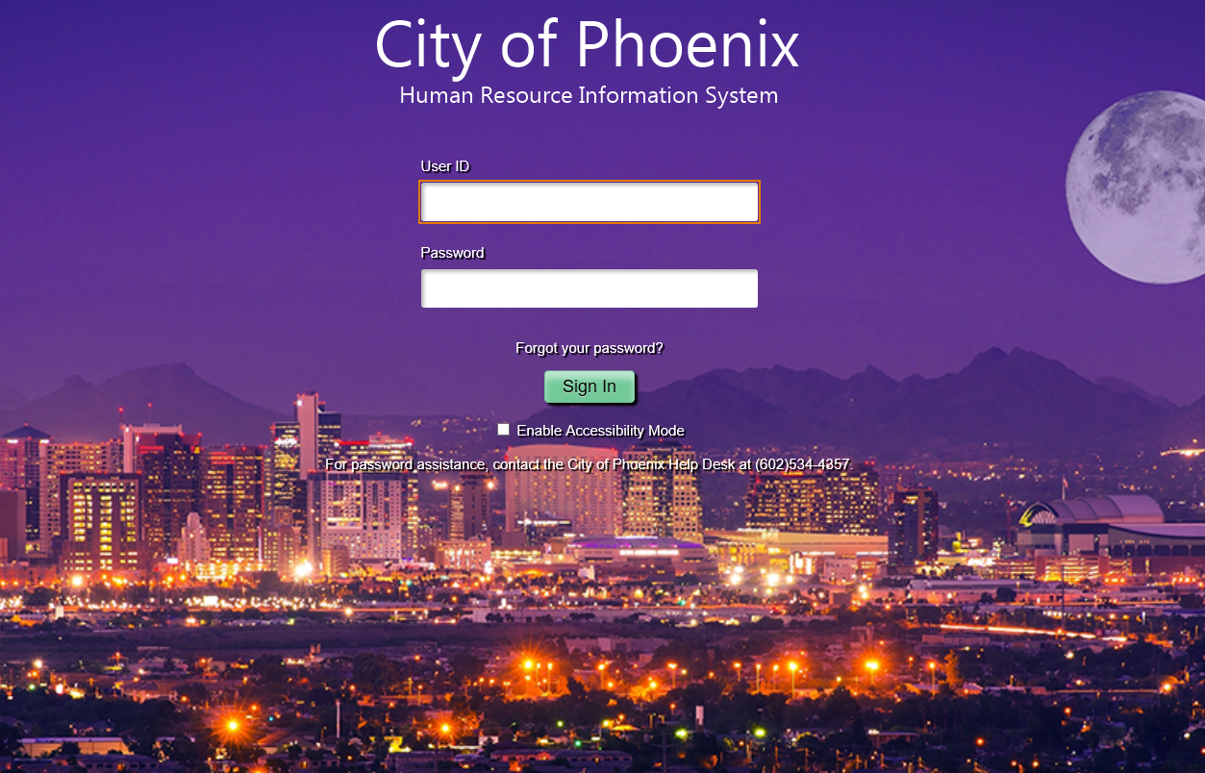

To change your federal and/or state tax withholding information, select the Payroll tile as displayed below.

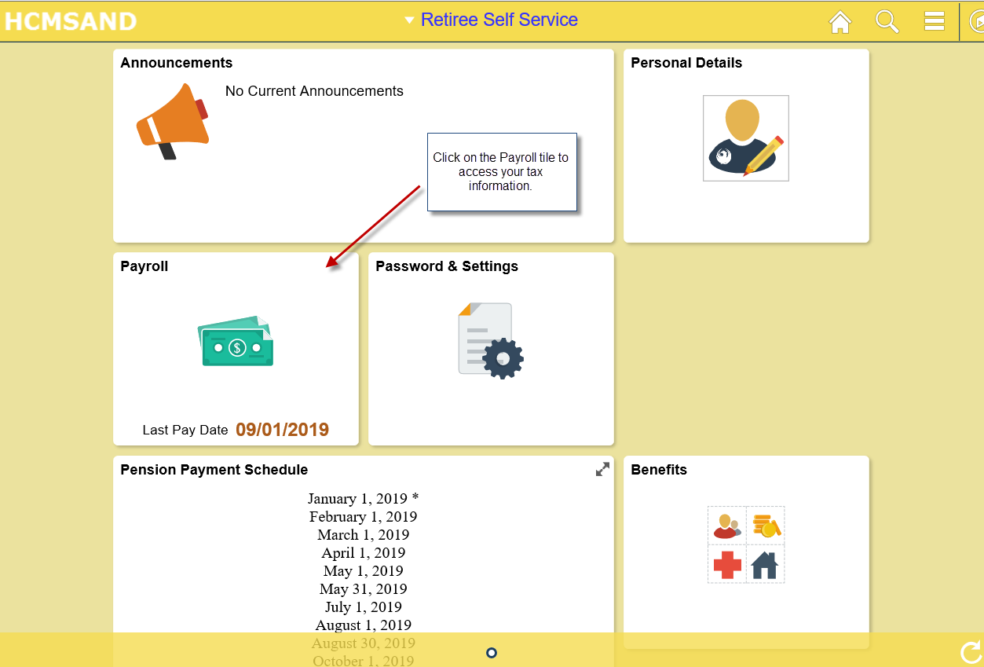

On the left side of the screen, select W-4, W-4P, A-4 & A-4P Tax Info to access your Federal and State tax information.

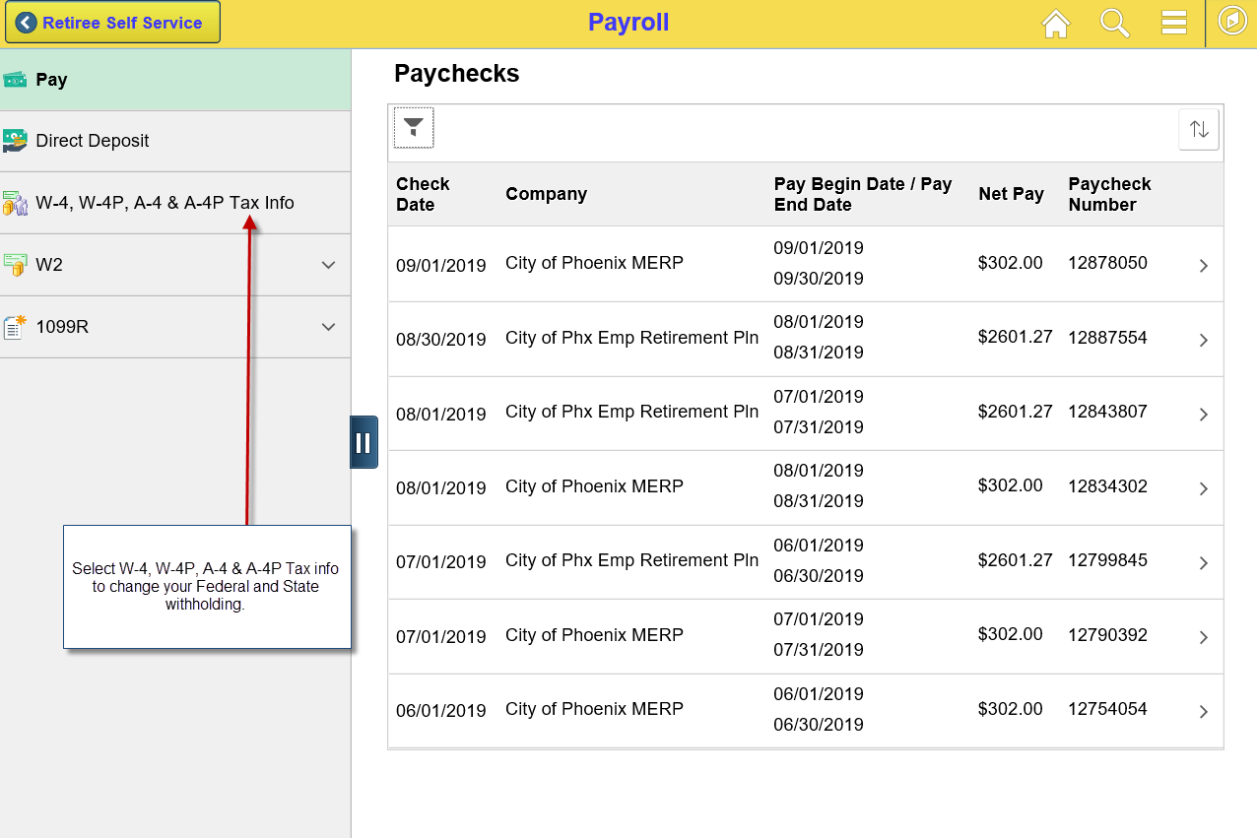

Identify the default tax record that first appears on your Tax Info page. Each Company has its own tax record and your monthly paychecks will be tax according to its set up. For example, MERP has its own tax information and Pension (City of Phx Emp Retirement Pln) has its own tax information. It is important to make sure you are changing your tax withholding in the proper Company, so the federal and state taxes are withheld accordingly.

In the example below, the City of Phoenix MERP is the default tax record. You want your federal and state withholding taxes to change for your pension paychecks. You need to switch the Company to City of Phx Emp Retirement Pln by clicking on the Company hyperlink.
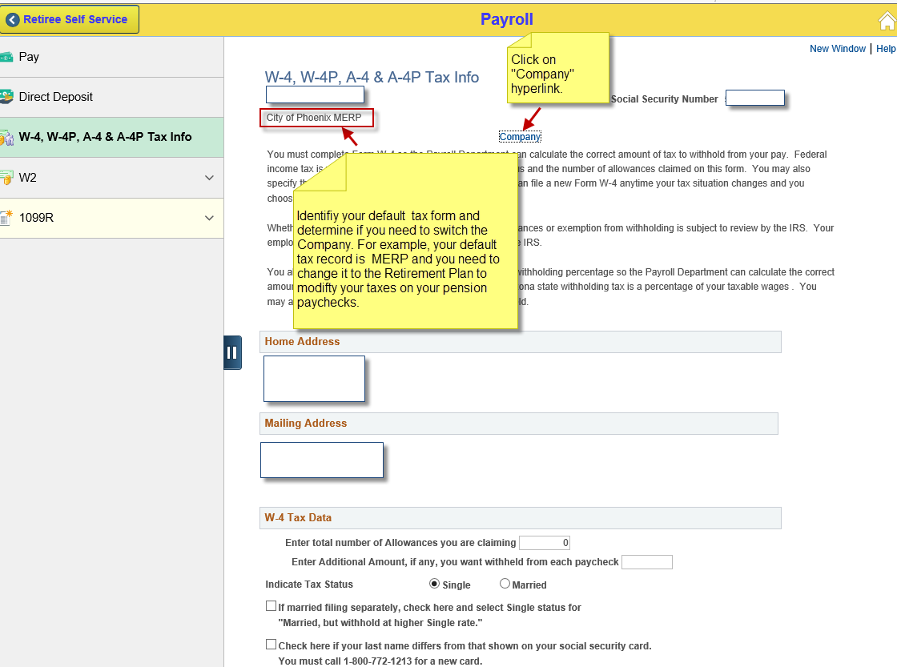

After you click on the Company hyperlink, a new screen appears as shown below. Click on the City of Phx Emp Retirement Pln hyperlink to change the company.

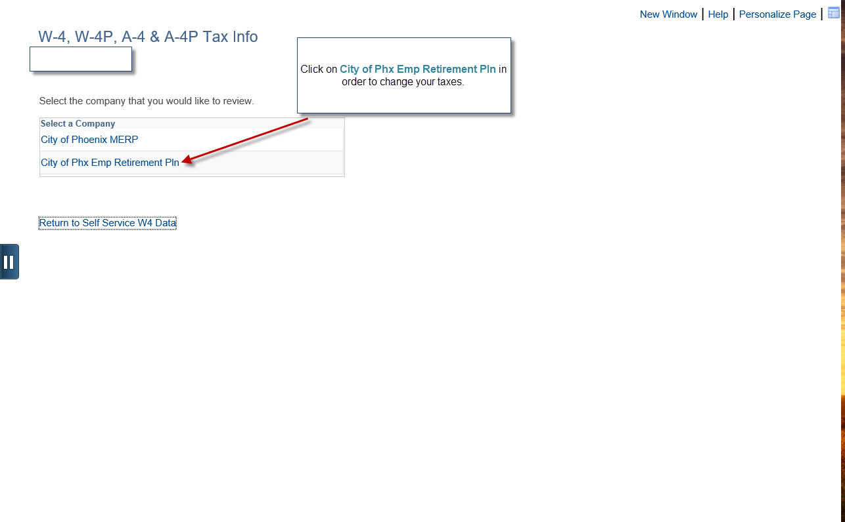

The City of Phx Emp Retirement Plan company will be displayed as described below. Use the scroll bar on the right-hand side of the screen to navigate the page.
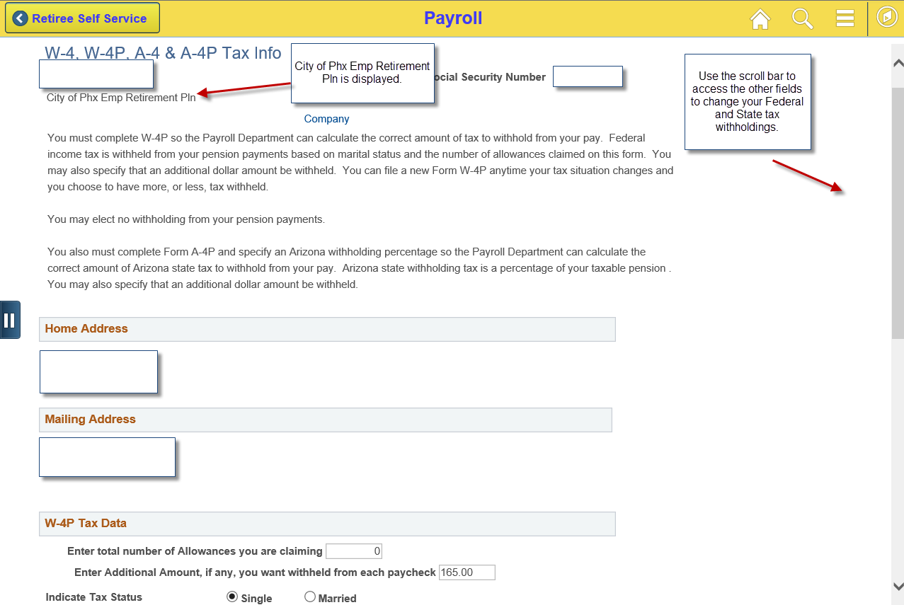

The W-4P Tax Data section is where you update your taxes for Federal withholding.
The A-4P Arizona State Tax Data section is where you update your taxes for State withholding.
Once you’ve entered your information, click on the Submit button.
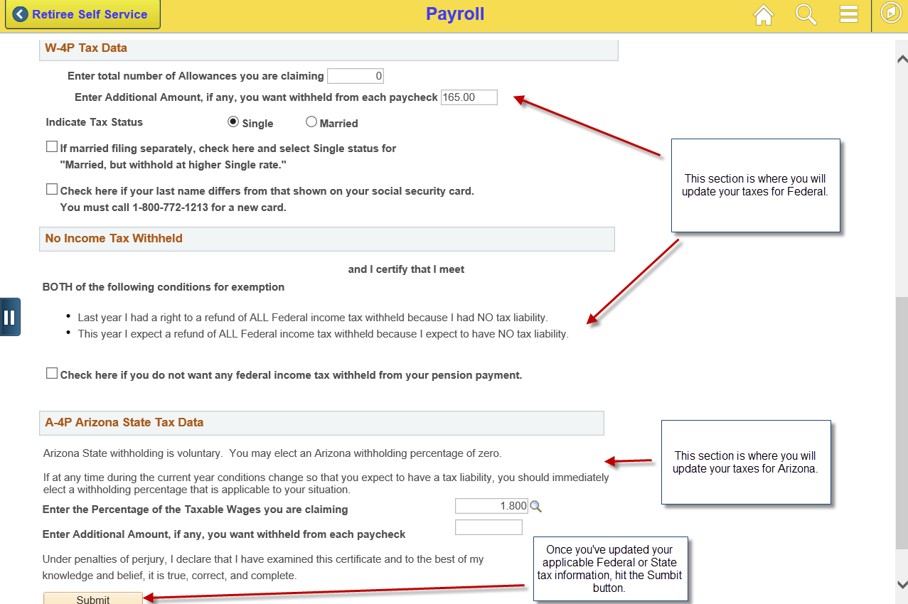

Enter your login password for eCHRIS then hit Continue. This is your electronic signature and it saves your selection.
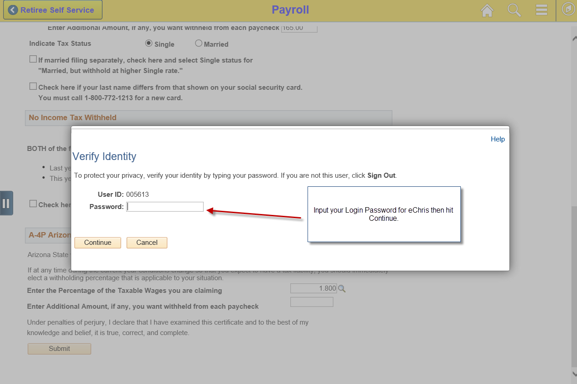

This screen is stating that you have submitted your information successfully. Next, click the Ok button. Once the Ok button has been selected, it will bring you back to your tax information page. Depending on the timing of your changes, it may require more than one paycheck for the changes to take effect. We recommend that you confirm your tax withholdings on your paycheck to ensure the desired tax withholdings was taken.
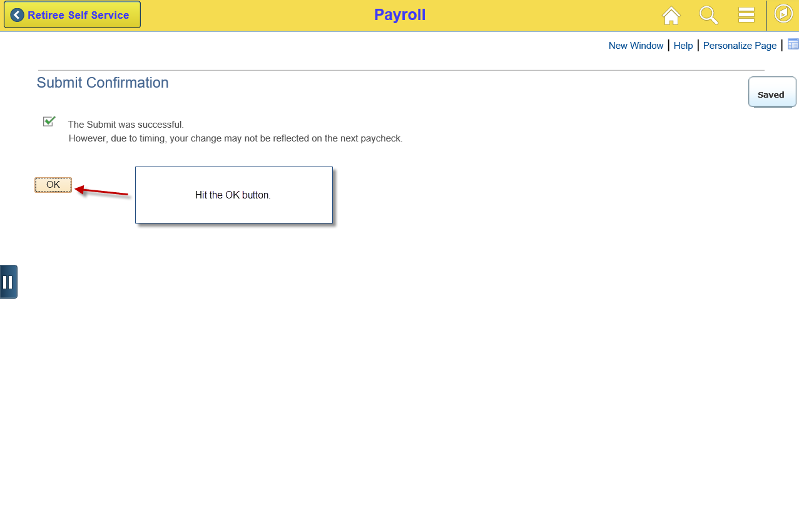

To sign out of eCHRIS, click on the three horizontal lines to access the menu. Once the menu comes up, click on Sign Out to exit eCHRIS.
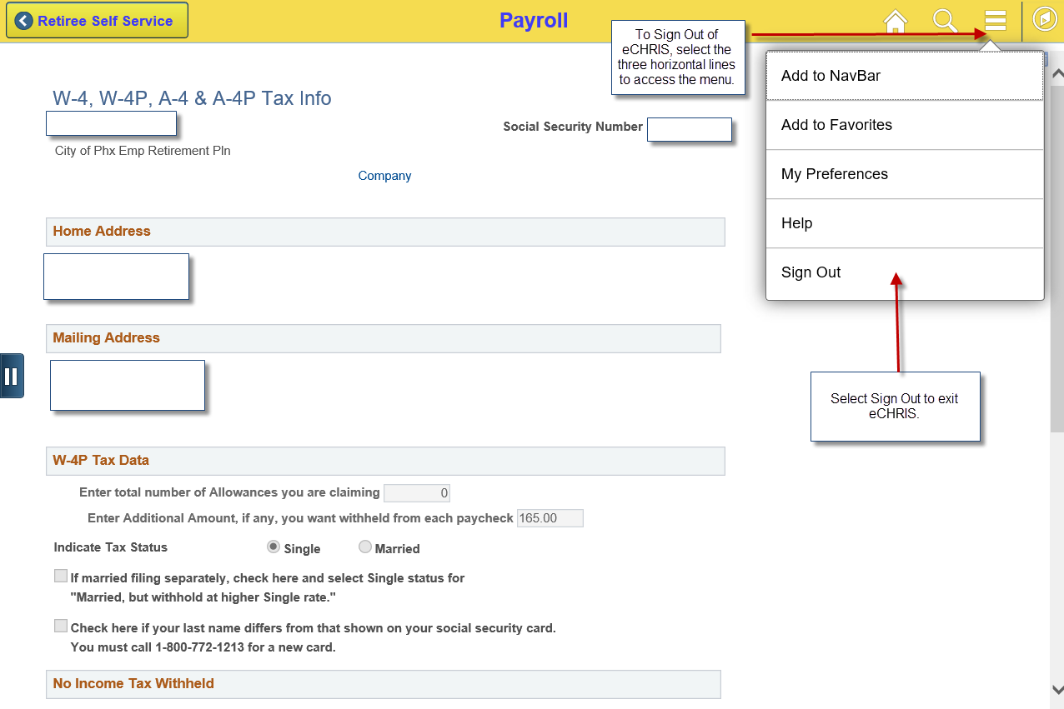
The next screen shows you have successfully signed out of eCHRIS.
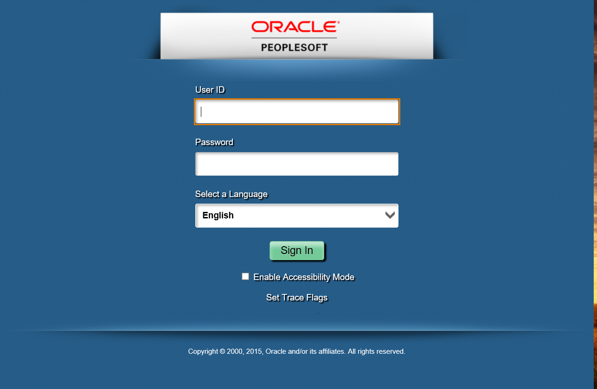
If you have any questions or need assistance changing your taxes in eCHRIS, please contact Central Payroll at 602-262-6555.

